Emma Hetrick

E 392M: Digital Research Lab: Medieval

Dr. Daniel Birkholz

12 May 2021

Bishops Registers’ and Biography and DH: Oh my!; Or, The Uses and Limitations of Bishops Registers in Biographical Exploration Using Digital Humanities Methods

1. Introduction

In Spring 2021, I worked on the Atlas of a Medieval Life[1] project at the University of Texas at Austin. The aim of the project, according to its website, is to “explore the ways in which computational methodologies and data-visualization platforms can bring the medieval subfields of literary studies, cartography, and biography into fruitful dialogue.” This is a hefty task, one that necessitates imposing limitations in order to produce results. The scope of the project, then, is to focus on one man, Roger de Breynton. Roger (c.1290-1351) is described on the project’s website as “a historically obscure but widely-travelled and well-connected Canon of Hereford Cathedral.” In other words, he’s a professional man from the Middle Ages who shows up in a lot of Medieval documents, but little secondary scholarship. He was introduced to me as a jack-of-all trades sort who performed various functions and traveled quite extensively during his lifetime.

The work I performed consisted mostly of extracting metadata from medieval documents and using that metadata to create data visualizations. The documents that serve as the primary sources for the Atlas of a Medieval Life project were selected because of their relevance to Roger de Breynton. The two types of documents we worked with were the Hereford Cathedral Muniments (HCM)—records typically related to land and Handlist—an assortment of documents selected because of Roger’s frequent appearance in them. Content from these documents was arranged by date, and usually included a brief description of a business interaction between individuals. Here is an example of text from one entry[2]:

HCM 2580

1305, in the Feast of St Bartholomew the Apostle [August 24].

1. John Lythfot, bailiff of the dean and chapter of the church of Hereford; 2. The said

dean and chapter, by the hand of dominus W., their receiver. QUITTANCE for twenty

shillings due in respect of his fee for the term of St. Michael, 1305 (33 Edw. I). Given at

Hereford. Latin.

Descriptive information we collected included “person,” “place,” and “occupation.” These documents collectively reveal information about relationships, exchanges of land and goods, and duties of individuals in a given area. This wealth of information begs the question: What other documents are out there? And what additional biographical information can they divulge? These questions are of particular relevance because our examination of the HCM and Handlist was not intentionally focused on producing information specifically about Roger de Breynton, although that is a main task of the project. I was given a type of document to look at: Bishops registers; and a person of interest: Adam Orleton. The question became: how useful are bishops registers as sources in biographical study, particularly in biographical study using DH methodologies?

2. Bishops Registers: A (Brief) History

Bishops registers were a form of literature most commonly used in the thirteenth-century through the mid-seventeenth century (Smith vii). In *Guide to Bishops’ Registers of England and Wales: A Survey from the Middle Ages to the Abolition of Episcopacy in 1646*, David M. Smith describes every existing bishop’s register in Canterbury and York during this time period. The result is a nearly three-hundred-page text. However, a number of the registers created in this period are no longer in existence due to mismanagement, deterioration, and damage.

The arrangement of each register varies by diocese. Smith outlines some general trends that can be observed when examining the registers holistically. He writes,

Firstly, a period of experimentation and the gradual evolution of an acceptable system of registration which usually attained its final form in the course of the fourteenth century [is followed by] the Reformation changes...a simplification in arrangement often tending towards a single, chronologically arranged, general register, with perhaps ordinations still kept separately (Smith ix).

Thus, although the printed form of the registers as recorded in Smith’s text are in chronological order, their contents had more atemporal, and even atopical, origins. In fact, registers were not usually bound up in book form until a change in bishop took place (Smith x).

According to Michael Clancy in *From Memory to Written Record: England 1066-1307*, bishops’ registers first resembled royal registers, leading to the “experimental and inconsistent” order, and organization of parchments stitched together in a long roll. However, as time went on, the registers became more similar to ecclesiastical registers on the European continent, which were more often in book form and chronological in order (76).

Generally, bishops' registers documented the administrative acts of a bishop and his officials. However, they are difficult to categorize because of the variety of contents within them. Smith suggests that “the main discursive feature of an episcopal register...is the record of institutions of clergy to benefices and related material” (Smith ix). In other words, the register provided the presiding bishop with information about “the incumbents of the parish churches, the patronage of the livings, the duties and responsibilities of the clergy and patrons, the pensions payable, the division of tithes, the provision of services and so forth” (ibid.). Sections included: institutions and collations, royal writs, ordinations, papal letters, confirmations, visitations, licenses (Smith x). Some orders of business are transcribed completely, while others are only briefly detailed.

3. Adam Orleton’s Registers

Adam Orleton had three registers: Hereford, Worcester, and Winchester. Of these registers, the ones from Hereford and Worcester are available in print form. I read through portions of each to get a sense of the kind of information available, and how it could be used in a digital humanities project about biography.

In a cursory examination of how bishops’ registers are used as primary sources in scholarship, I found several examples. John Aberth in “The Black Death in the Diocese of Ely: The Evidence of the Bishop's Register” references the register of Thomas de Lisle, bishop of Ely from 1345 until 1361, to measure the toll of the fourteenth-century plague in different parts of the bishop’s jurisdiction. Aberth writes, “The evidence of the register of Thomas de Lisle, bishop of Ely, while not perfect, is probably the best source that we have as to the mortality caused by the Black Death of 1348-9 in all of Cambridgeshire (286). In “Administrative Efficiency in Fourteenth-Century England: The Delivery of Writs Based on Evidence from the Register of Bishop Martival,” Michael Ray refers to the register of Robert Martival, bishop of Salisbury from 1315 to 1330, as an illuminating text about fourteenth-century English bureaucracy and travel. Interestingly, both of these papers primarily attend to the registers as sources of statistical information, and prominently feature tables with data collected from the registers. The engagement I perform and imagine with Orleton’s registers is in some ways also of a statistical nature, but one that also duly accounts for the persons the statistics are about, and the materiality that the statistics are displayed in.

Registers reveal information about who was in a bishop’s circle. For example, some of the most popular names that appear in Adam Orleton’s Worcester register are the King of England and the Pope of the Catholic Church. The summary for an entry on December 18, 1317 in Orleton’s Hereford register reads, “The Bishop, by direction of the King, writes to the Dean and Chapter that they receive to the Prebend of Withington Hugh de Leominster, who was duly presented by the King during the Vacancy of the See” (Bannister 50). On December 2nd of the same year, “The Bishop, by direction of the Pope, grants to Roger Inkepenne a license to found and endow a chaplaincy in the cemetery of the Nuns of St Mary’s, Winchester” (Bannister 51). A future iteration of this inquiry then, may replicate the kind of metadata analysis and visualization of HCM and Handlist documents with the registers, to construct a network of historical characters interacting with each other, in person, or in documentation.

As Michael Ray’s article begins to get at, registers can also tell us about the travels of medieval figures. They document conferences attended, vacancies that needed to be temporarily filled due to travel, and visits to other dioceses. Oftentimes, entries about travel describe actions the bishop took while away from his seat. On February 3, 1321, “The Bishop, having found, on his visitation, that the Portionists of Westbury had not proceeded to Holy Orders, and had thereby vacated their prebendal portions, instructs the Dean of Pontesbury to call upon the Patron to present fit persons to the said Church” (Bannister 180).

Registers can also be sources of information about the politics of the day, with a particular focus on who is allied with or against the other, and when particular moments of dispute occur. It is not clear to me, however, if this is more representative of Orleton as a person, who, according to biographer R. M. Haines, had his fair share of run-ins with the King of England and private consultations with the Pope. Haines writes, “We can discover a great deal about his [Orleton’s] actions, but very little indeed about the motives which inspired them” (x). A more rigorous analysis of Orleton’s bishop’s registers would provide some insight into these motives; after all, the registers, to an extent ,represent how he wanted to be seen and perhaps even remembered as bishop.

Most surprisingly, bishops’ registers can also reveal the duties of a bishop that would have not been in the “official” list of job responsibilities. For example, on February 9, 1321, “The Bishop, to silence calumny, certifies, from his own knowledge, that Walter Penk, a Monk of Tintern, but a native of Hereford, had always been recognised as one born in lawful wedlock” (Bannister 185). It’s entries like these that are most likely to give life to a biographical study of a medieval figure like Orleton.

4. From Ink to iPad: Reading Digitally and Digitally Reading

Reading and analyzing the bishops registers online is an interesting experience for several reasons. Firstly, even though the registers that I examined were in print form, the main text of the Hereford register is entirely in Latin, a language I have no training in and cannot read. This limits the amount of information I’m able to derive from the text.[3] Instead of reading the main text of each entry, I have to rely on the editorial summary. Perhaps surprisingly, I found this to be a productive and thought-provoking exercise. As someone who primarily studies novels from the nineteenth-century, I have become a firm believer in the importance of paratext. In fact, I would argue that paratext is just as necessary as the main text of a document in the literary and historical analysis of a text.[4] In the preface to Adam Orleton’s Hereford register, Bannister writes of Canon Capes, the General Editor of the Cantilupe Society’s publications, “he has generously bestowed more time and thought upon another’s work than most men devote to their own.” With this sentiment in mind, an examination of edited bishops’ registers may also reveal significant insights about the editor themself. The Worcester register presents a different situation, because it is entirely translated into English. When reading it, I am reminded of the fact that I am reading a translation of a printed version of an edited text originally written as a manuscript. Not being able to read the main text of the registers is less of a limitation, and more of an opportunity to consider overlooked portions of the registers, like editorial interventions and paratext written in English. Furthermore, it presents the reader with the opportunity to consider more critically how the text came into being, and what bearing that has on what content they are reading. Figures one and two, below, show a side-by-side comparison of one page from a photograph of Orleton’s Worcester record and a digitized, print edition of his Hereford register.[5]

In *From Memory to Written Record*, Michael Clancy offers an interesting and relevant analysis of doing research with medieval records in manuscript and print form. He writes,

While admiring manuscript culture and trying to convey to the reader its special qualities, every author must acknowledge the advantages which printing has brought to scholars by making uniform texts available in multiple copies. Furthermore, generalizations cannot often be made directly from medieval manuscripts, because each one usually requires detailed study and presentation by an editor (to establish the best text, assess the date, identify persons, and so on) before it can be adequately understood. Editing texts and generalizing from them in books like this one are different endeavours (4).

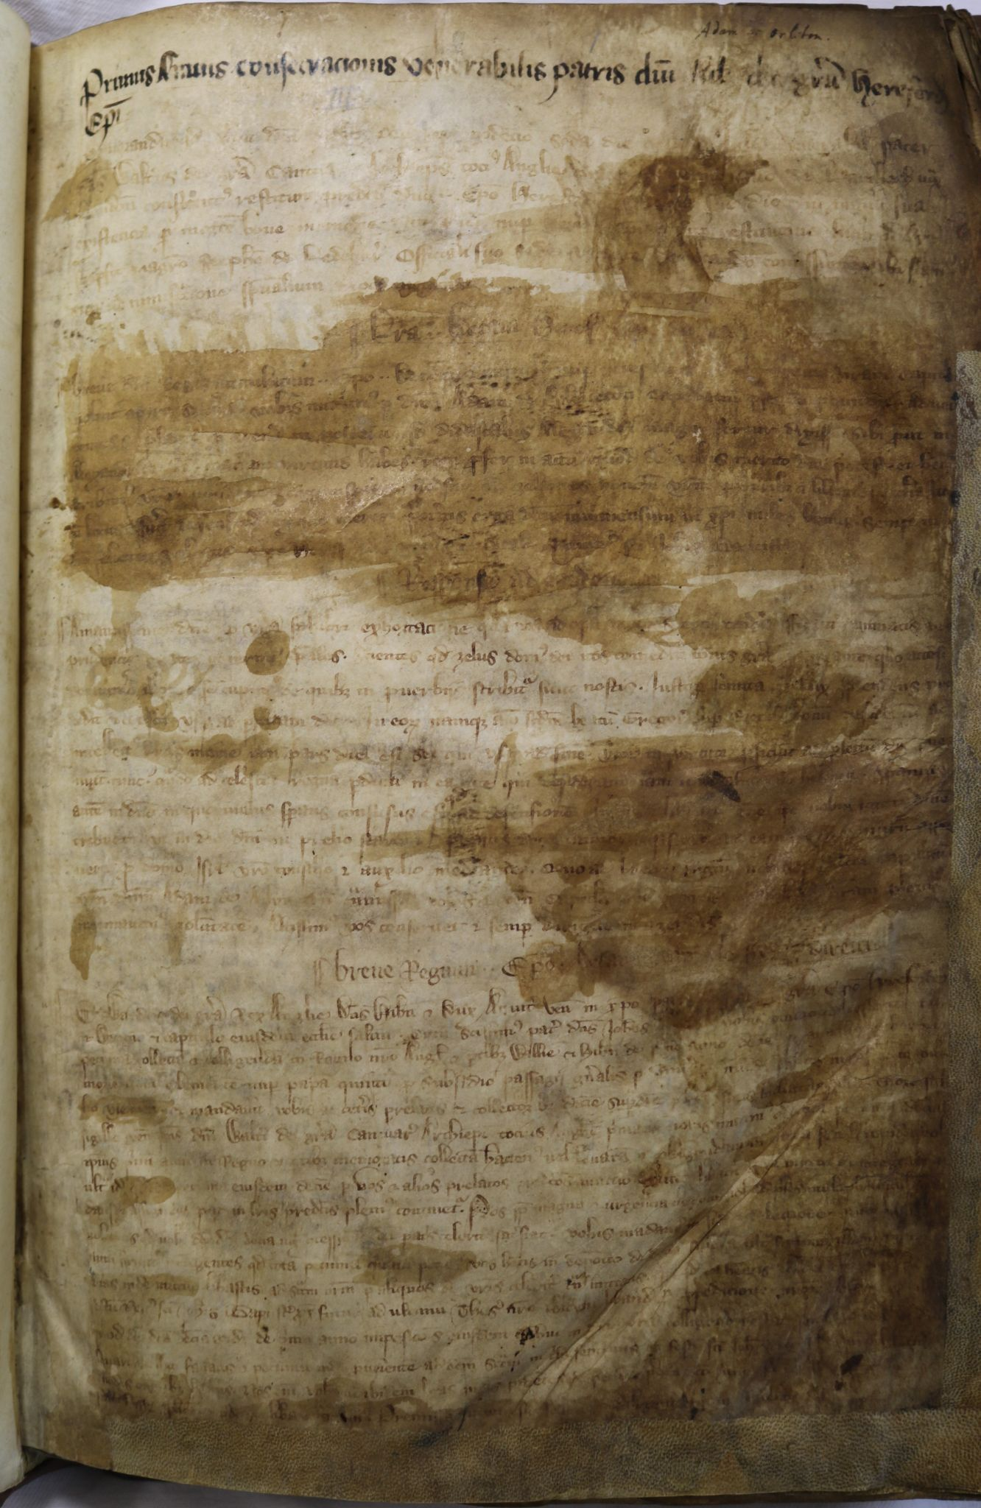 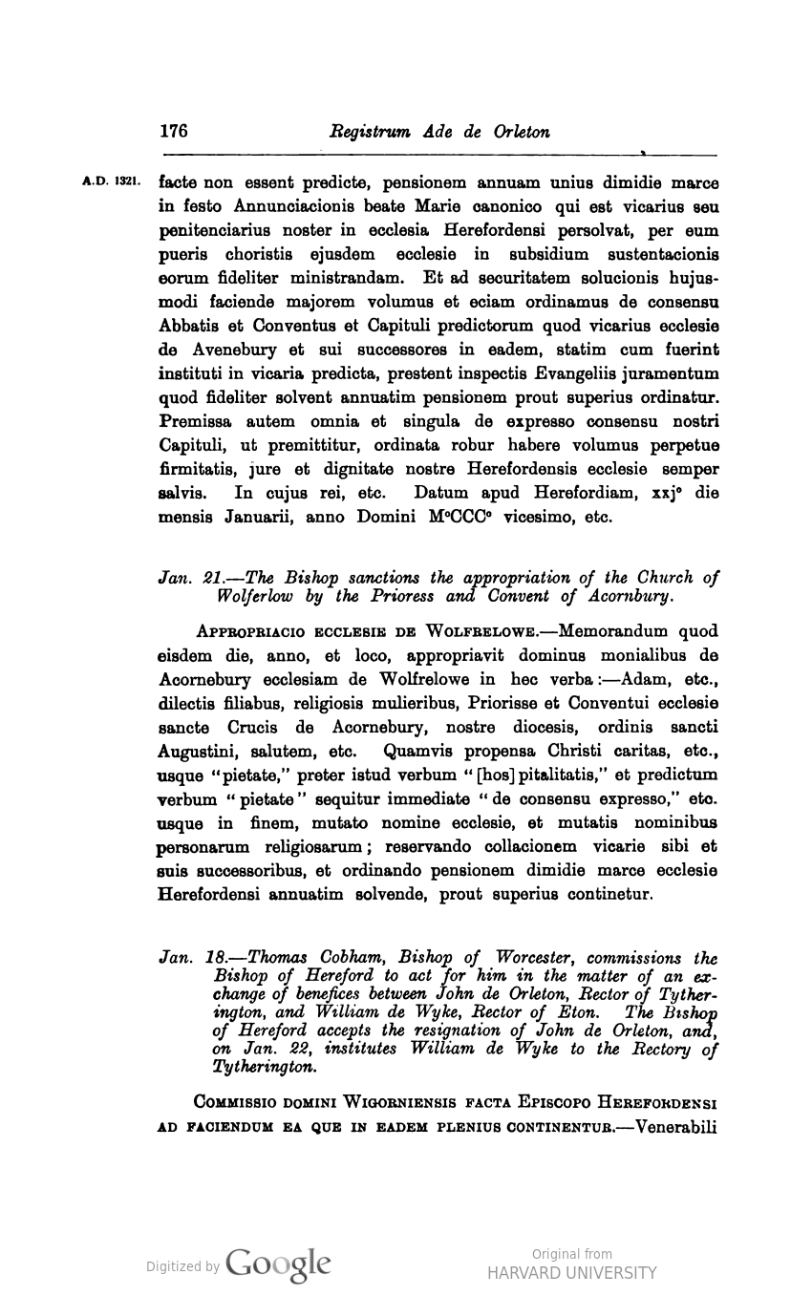

Fig. 1 Fig. 2

Similarly, I am invested in legitimizing the print form, moreover, the digital form, of texts that are glamorized to an extent for their manuscript qualities. In doing so, I want to trouble the idealization of the lone researcher in a library’s reading room hunched over a manuscript centuries old. I am not interested in critiquing this form of engagement with a text[6], but rather want to challenge our often limited ideas of what engagement with a text can look like. Being able to access texts online means that they can come to you (so long as where you are is near an electronic device with an internet connection), rather than you having to go to them.

Furthermore, and most importantly, online engagement with texts enables a form of collaboration and annotation that is not available in the reading room. English scholar Martha Woodmansee writes, “The compiler of the Renaissance commonplace book[7] composed, transcribed, commented on, and reworked the writings of others—all in apparent indifference to the identity of their originators and without regard for ownership. This quintessentially Renaissance form of reading and writing is rapidly being revived by our electronic technology” (27).[8] When one collaborator in the *Atlas of a Medieval Life* project annotated an entry from the HCM and Handlist documents, another collaborator could access the same annotations and add to or edit them.

I hope it is clear by now that bishops’ registers offer a wealth of information for biographical study. Furthermore, they are ripe for digital humanistic analysis precisely because of their rather hodge-podge print culture trajectory. In her biography about Cecilia Penifader, a woman of the peasant order from the fourteenth-century, Judith Bennett writes, “We know about peasants and their lives indirectly--from the writings of their social superiors” (3). Adam Orleton, as a clergyman, was one of those “social superiors.” Another equally productive biographical exercise when examining bishops’ registers would be to see what information about peasants can be gleaned. Why was Walter Penk in a situation where he needed Orleton to say that he was born out of lawful wedlock? In his text, Clancy positions book history as an archeological act,

To gauge the value and meaning of the subject matter, everything that comes out of the trench – however small or obscure – must be investigated, while the archaeologist recognizes at the same time that the contents of the trench are only an arbitrary cross-section. Where to dig the trench is a matter of judgement and luck; both historian and archaeologist work in the light of experience (20).

I want to take up his call to consider everything, “however small or obscure,” in future explorations of the bishops’ registers for the *Atlas of a Medieval Life* project, but drop the excavatory language, because I think it neglects the care that must be taken when working with historical material. Archival Studies scholars Michelle Caswell and Marika Cifor argue, “Archivists [and, I would add, book historians] have affective responsibilities to other parties and...that these affective responsibilities should be marked by radical empathy” (24-25). What does it mean to center both the historical actors who appear in the registers and the persons whose work went into their production, in the text that you, that I, as the reader, is reading? I think this is a particularly pressing question when doing digital research, which often, as those working on the *Atlas of a Medieval Life* project attested to, can lead one to easily dissociate from the affective experience of engaging with the text.

Works Cited

Aberth, John. “The Black Death in the diocese of Ely: The evidence of the bishop's register.”

*Journal of Medieval History*, vol. 21, 1995, pp. 275-287, <https://doi.org/10.1016/0304-4181(95)00771-7>. Accessed 11 May 2021.

Bannister, A. T. *The Register of Adam de Orleton: Bishop of Hereford (A. D., 1317-1327)*.

Hereford: Wilson and Phillips, 1907.

Bennett, Judith M. *A Medieval Life: Cecilia Penifader of Brigstock, c. 1295-1344.* McGraw Hill

College, 1999.

Caswell, Michelle and Marika Cifor. (2016). “From Human Rights to Feminist Ethics: Radical

Empathy in Archives.” *Archivaria*, vol. 81, 2016, pp. 23-43,<https://escholarship.org/uc/item/0mb9568h>. Accessed 11 May 2021.

Clanchy, Michael. *From Memory to Written Record: England 1066-1307.* Third Edition, E-book,

Wiley-Blackwell, 2013.

Haines, Roy Martin. *Calendar of the Register of Adam de Orleton: Bishop of Worcester*

*1327-1333*. London, Historical Manuscript Commission, 1979, <https://babel.hathitrust.org/cgi/pt?id=uc1.b3387631&view=1up&seq=8>.

--*The Church and Politics in Fourteenth-Century England: The Career of Adam Orleton*

*c. 1275-1345.* Cambridge University Press, 1978.

Hereford Cathedral Muniments, Handlist, and other assorted documents. Materials collected by

Dan Birkholz and Liz Fischer for the *Atlas of a Medieval Life* project.

Ray, Michael. “Administrative efficiency in fourteenth-century England: the delivery of writs

based on evidence from the register of Bishop Martival.” *Historical Research*, vol. 84, no. 223, pp. 14-27, <https://doi.org/10.1111/j.1468-2281.2009.00529.x>. Accessed 11 May 2021.

Smith, David M. *Guide to Bishops’ Registers of England and Wales: A Survey from the Middle*

*Ages to the Abolition of Episcopacy in 1646.* London, Royal Historical Society, 1981.

Woodmansee, Martha. “On the Author Effect: Recovering Collectivity.” *The Construction of*

*Authorship: Textual Appropriation in Law and Literature,* edited by Martha Woodmansee & Peter Jaszi, Duke University, 1994, pp. 15-28.

1. The Atlas of a Medieval Life website can be found at the following URL: <https://sites.utexas.edu/atlasofamedievallife/>. Though currently sparse, one can imagine it becoming populated with information as the project picks up more collaborators and results.
2. The HCM and Handlist documents had been compiled from various sources prior to when I joined the project team. In order to extract data from the documents, we first transcribed images of them so that the text could be machine readable. We then used an online tool called Recogito <https://recogito.pelagios.org/>, which enables users to annotate portions of text.
3. Although I am not certain, I imagine that there is optical character recognition software that can translate written text in one language into machine readable text in another.
4. For example, one might think they were reading two different novels if they looked at the title page alone of Harold Frederic’s 1896 novel, published as *The Damnation of Theron Ware* in the United States and *Illumination* in England.
5. I could not display a page from the digitized, printed edition of the Worcester register because it is copyrighted.
6. In fact, what spurred my interest in print culture, was my first sit-down in a reading room in undergrad with an 1839 London and 1841 Philadelphia edition of Charles Dickens’s novel *Oliver Twist.* 
7. The Renaissance, albeit, isn’t quite the time period the Atlas of the Medieval Life project is working in, but I believe Woodmansee’s point still stands for the medieval period and bishops’ registers.
8. I was able to find this quote in an online version of Woodmansee’s article because I had highlighted it on my iPad when I read the article for another paper.